|  |
| --- |
| Functional Specification – Data Upload Report with Call Transaction Using FM |

|  |  |
| --- | --- |
| **1. Project:** | |
| **2. FS Name:** Master Purchase Order Text view | |
| **3. Reference: NA** | **4. Business Process:** |
| **5. SAP Module:** MM | **6. Business Sub Process: Report/Upload** |
| **7. Author:** | **8. Reviewed By:** |
| **9. Status:** <Created/  Reviewed/Approved> | **10. Status Date:** |
| **11. Priority:** <High/ Medium /Low> | **13. Process Owner : Upendar Reddy N** |
| **12. Version No: 1.0** |  |

13. Document Revision History:

|  |  |  |  |  |
| --- | --- | --- | --- | --- |
| **Rev. No.** | **Change Request No.** | **Affected Pages** | Description of Change | **Date of Revision** |
|  |  |  |  |  |
|  |  |  |  |  |
|  |  |  |  |  |
|  |  |  |  |  |
|  |  |  |  |  |
|  |  |  |  |  |

14. Definition:

|  |  |
| --- | --- |
| **Migration Title:** | Upload the purchase order text |
| **Associated Business Event:** |  |
| **Application:** | MM |
| **Comments:** |  |

15. Purpose:

The purpose of this Report Program is to upload the purchase order text from flat file (Excel Sheet with ‘;‘ Separator) upload the same in Material Master (MM01/02) for Purchase Order Text view/tab.

16. Assumptions:

NA

17. Interface - Business Process Description:

Not Applicable

18. Conversion Type:

Function Module Data upload

19. Periodicity:

As & when required

20. Process Flow Diagram:

NA

21. Processing Logic:

Develop report which reads the Purchase Order Text from flat file (Excel Sheet with ‘ ; ‘ Separator) upload the same in Material Master Purchase Order Text view.

Note: it’s Not a BDC Session Method Program and not required any BDC Performs and forms.

Use the below functions to upload the data then finally call the Call Transaction Statement to load the data.

CALL FUNCTION 'SAVE_TEXT' - Main Function for this upload program

CALL FUNCTION 'F4_FILENAME’ - Function to pick the file

CALL FUNCTION 'ALSM_EXCEL_TO_INTERNAL_TABLE' - Function to read the Excel

CALL TRANSACTION 'MM02'

The Program will upload text from **Data Upload Sheet - DUS** into Material Purchase Order text as shown below.

Transaction: MM02 to check the values are inserted or not.

**OUTPUT: Upload Screen**

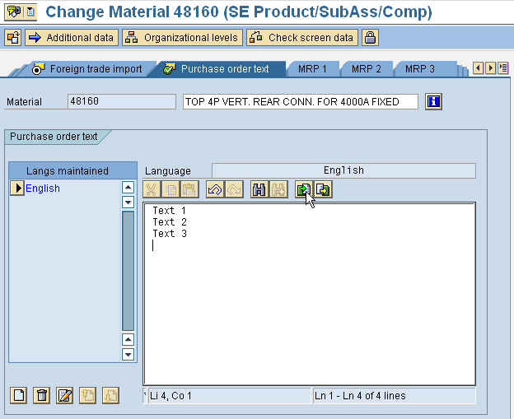

Data Upload Sheet - DUS



Note for DUS Sheet: 1) Consider the Existing Material Numbers (MM02) only in the excel sheet and not required the DUS Sheet example Materials 48160 etc.

2) The DUS Source Sheet should consider both the languages EN (English) and FR (French). But need to upload only EN (English) related purchase order text.

22. Reporting:

AS specified in OUTPUT. Ref 21. Processing Logic:

23. Selection Screen:

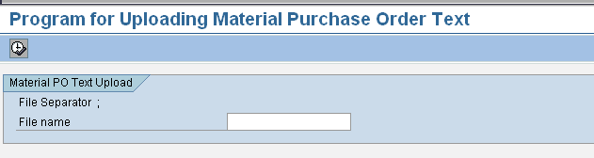

Develop a Report Program which reads the Purchase Order Text from flat file DUS and uses the Functional Module SAVE_TEXT to upload the same in Material Master Purchase Order Text view/tab.

The structure of the Input file Data Upload Sheet - DUS for the Upload program is shown in the attached layout at Data Upload Sheet - DUS

The flat file consists of the Material Number in the SAP System. If the Material Number (MATNR) is not available in then the system should display the standard error message in the output of the program. To check the materials pass the values of material numbers to MARA table.

24. File (Input/Output) Format:

|  |  |  |  |  |  |  |  |
| --- | --- | --- | --- | --- | --- | --- | --- |
| Sr. No. | Field Name | Field Type | Field Length | Format | Mandatory | Validations/Comments | Field Mappings |
|  |  |  |  |  |  |  |  |

**NA**

**25. Field Mappings:**

**Table Definitions**

|  |  |  |  |  |
| --- | --- | --- | --- | --- |
| **Sr. No.** | Field name | **Data Type** | Length | **Primary Key/Remarks** |
|  |  |  |  |  |

26. Participating Systems:

NA

**27. Sign-Off**

|  |
| --- |
| Signed-Off By: |
| Sign-Off Date: |